Esqueleto

Android Estudio V3.0.17/Flutter

Objetivo:

F.Creación: 1-4-2018

Programa:esqueleto

Fuente:tutorial dart

Esqueleto de pantalla principal
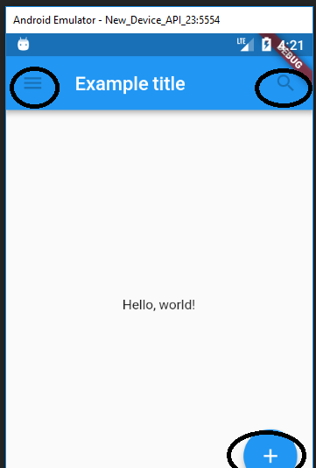

import 'package:flutter/material.dart';
void main() {
runApp(new MaterialApp(
title: 'Flutter Tutorial',
home: new TutorialHome(),
));
}
class TutorialHome extends StatelessWidget {
@override
Widget build(BuildContext context) {
// Scaffold is a layout for the major Material Components.
return new Scaffold(
appBar: new AppBar(
leading: new IconButton( //primer circulo
icon: new Icon(Icons.menu),
tooltip: 'Navigation menu',
onPressed: null,
),
title: new Text('Example title'), //el título
actions: <Widget>[
new IconButton(
icon: new Icon(Icons.search),
tooltip: 'Search',
onPressed: null,
),
],
),
// body is the majority of the screen.
body: new Center(
child: new Text('Hello, world!'), //el texto centrado
),
floatingActionButton: new FloatingActionButton( //el botón flotante
tooltip: 'Add', // used by assistive technologies
child: new Icon(Icons.add),
onPressed: null,
),
);
}
}

